Timesheet Approval CBT Story Line

Part One: How to get to timesheet approval window:

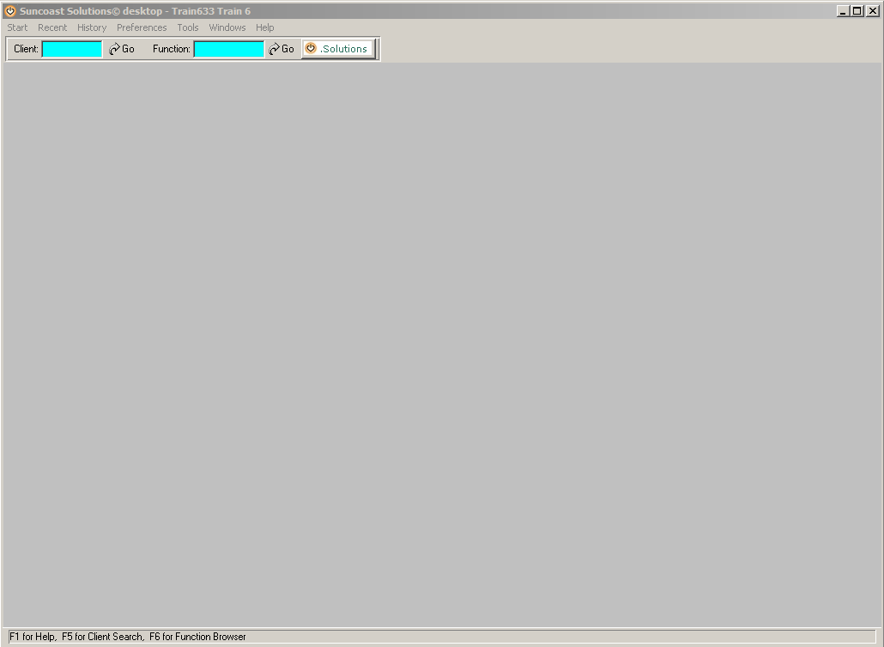

Click on solutions button. Moves to next view…

Notes:

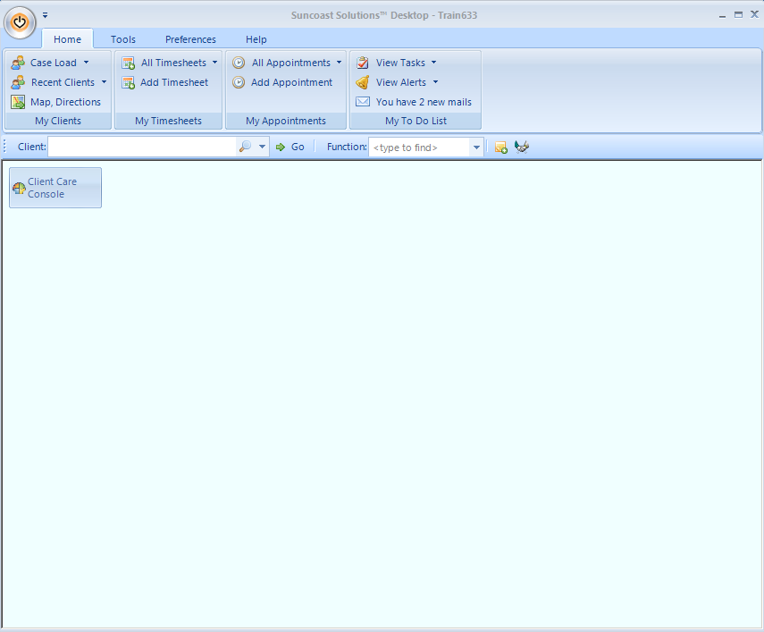

Explain how to add the time sheet approval button to favorite’s desktop. When user clicks on solutions icon it will take them to this view

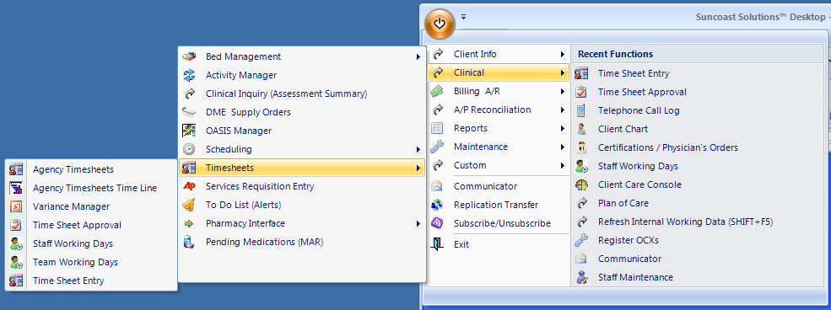

Explain what they have to do:

* Choose timesheet approval, or;
* Add to favorites desktop

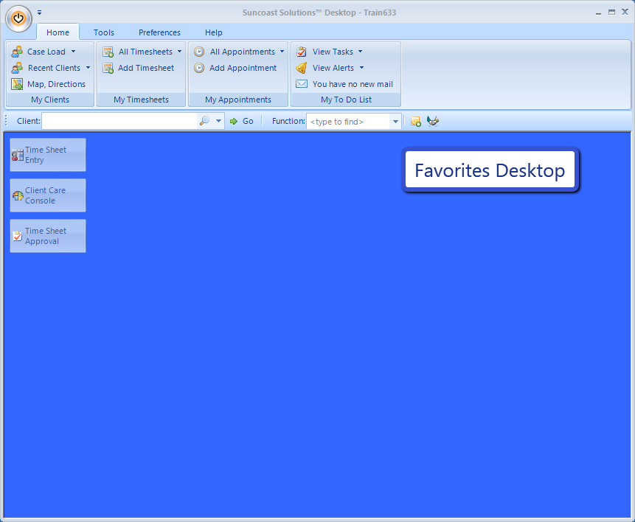

This view shows the outcome of placing the timesheet approval in the favorites desktop.

Next user clicks on time sheet approval button

The time sheet approval window shows next

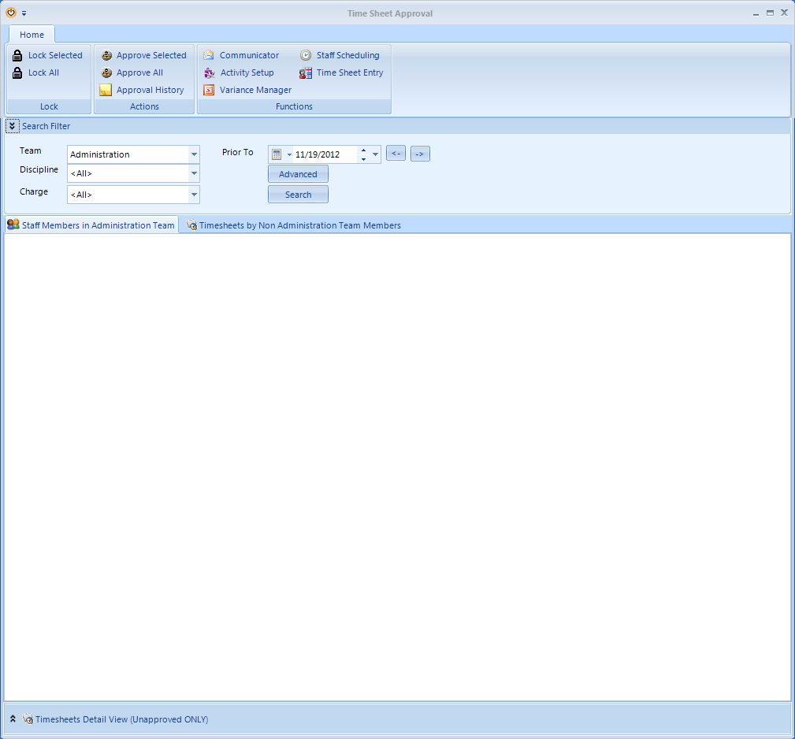 END of Part ONE

Part II: Explain Parts of Time sheet Approval Interface:

1. Home tab



User mouse over each icon that directly relates with timesheet approval and demonstrate a rollover text, containing, a succinct explanation of use

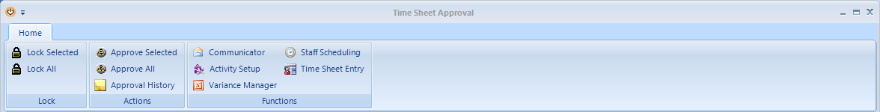

1. Search Filter Part



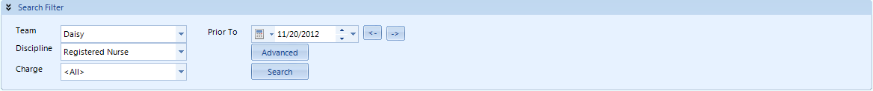

* Go through each drop down space- rollover text
* Have user click the “prior to” and advance button—this will take to the next view

1. Close up of “Calendar” and “Advanced” button

Previously the user clicked on the framed icon. Start with this view. Succinct explanation of use

NEXT- Calendar

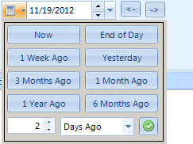

Succinct explanation of use.

NEXT- Advanced button

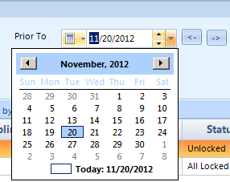

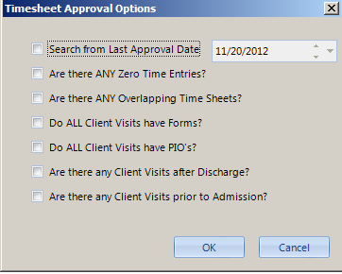

Succinct explanation of use of each approval option

1. Search Outcome View



Explain column headers, sorting- rollover text

Explain the tab views- team and non-team- rollover sidelet

Have user double click on the client view, this will take them to Opening a timesheet.

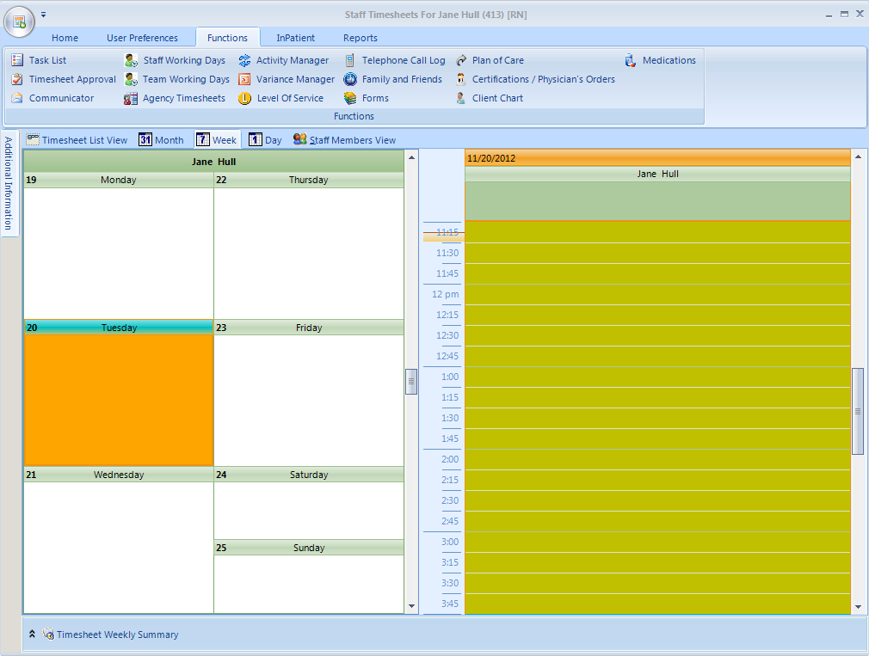

To review timesheet have user click on framed day. This will open NEXT : Add time sheet view

From this view use rollover text to explain the **functions** tab items.

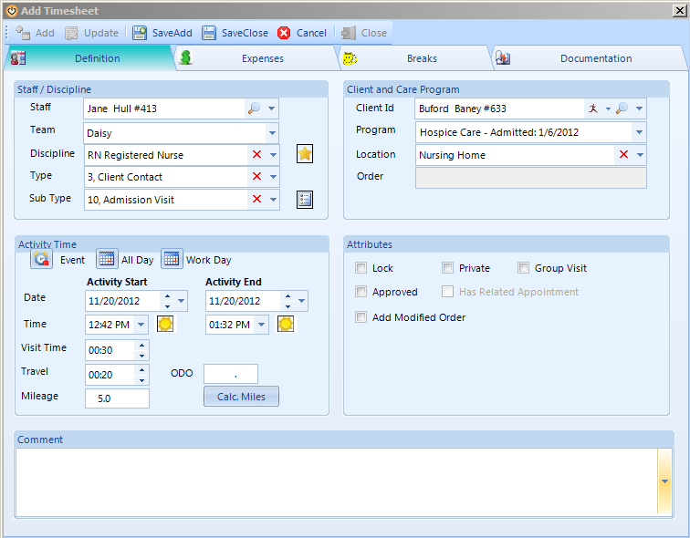

Perhaps suggest to user if they want more detail on timesheet entry to request timesheet module

Part III: Training Simulations 3 Parts:

Simulation One: steps from logged in window to timesheet approval window.

Simulation Two: Reviewing unlocked visits option 1 (Timesheets detail view –unapproved ONLY)

Simulation Three: Reviewing unlocked visits option 2 (Group by function)